Hello!

Welcome to Gateshead’s Summer 2024 SEND Network Newsletter.
For more information about the SEND services available to you, go to www.gateshead-localoffer.org, follow the Gateshead SEND Local Offer Facebook page or visit the Gateshead Local Offer YouTube channel.

Tom’s Pathway to Employment
A young Gateshead resident has started his journey into employment, thanks in part to Gateshead Learning and Skills’ Supported Internship Programme. Nineteen year old Tom enrolled on the programme in September 2023 as a means of developing the skills and experience needed to move into paid employment.
Staff on the programme supported Tom to complete a full vocational profile and develop his employment skills during classroom sessions, and in January 2024 Tom started his placement at Saltwell Park working with Gateshead Council’s Grounds Maintenance team.
From the start he approached every task with enthusiasm, learning the role and developing his confidence. Training was also provided to give him experience in using the team’s specialist equipment.
Tom has now been offered a place on the Gateshead Council Waste Operative Apprenticeship which will further his career within the Council. “I would not have got the job if it was not for the staff at Birtley”, Tom says. “I am so pleased to have a job and work mates who I can go to the pub with!”
Gateshead Learning and Skills still have some places left on their Supported Internship programme for September 2024. If you are a young person with SEND and would like help and support to move into work like Tom, please contact supportedinternships@gateshead.gov.uk or call 0191 433 8545.

Gateshead SEND Futures Event
Gateshead hosted its first ‘SEND Futures’ event in June at The Fed in Dunston. The free event showcased the support available in Gateshead for children and young people with SEND and their families, and was developed by the Local Authority in partnership with Gateshead Council Learning and Skills.
Over 100 families attended, gaining valuable information from the attending organisations which included partners from across the local health, education, social care and transport sectors.
Helen Fergusson, Strategic Director for Children's Social Care and Lifelong Learning, said: "We're proud to host our first Gateshead SEND Futures event to bring the range of support on offer to our young people with SEND and their families. We know that many parents and carers of children and young people with SEND aren't sure who to turn to for support, which is why it's so important that we make our Local Offer as visible as possible.”
For more information about Gateshead’s SEND Local Offer go to www.gateshead-localoffer.org

Gateshead PCF

Gateshead’s Parent Carer Forum now have a permanent office in the Blaydon Winlaton Family Hub. Weekly drop-in sessions for parents and carers are located here every Tuesday and Thursday from 9.30am to 11.30am. These sessions offer support to parents and carers who would like to speak to someone face to face, either to seek advice or just to have a hot drink and chat with someone who understands what you are going through.

Additionally, the group have organised a free Family Fun Day event for children with SEND in Gateshead and their families to be held at Dunston Activity Centre on Friday 2nd August, 1:30pm-3:30pm. There will be a buffet, arts and crafts, soft play and a bouncy castle!

Tickets are limited, so please contact info@gatesheadparentcarerforum.co.uk for details on how to reserve your place. For more information about the group, visit https://www.gatesheadparentcarerforum.co.uk/

UNITY Community Base

Unity Community Base provides activities to suit the interests, hobbies and aspirations of young adults with complex learning disabilities, inspiring people to reach optimal levels of self-care skills and independence. Their aim is to enable people to become as independent as possible and will support each individual to reach their full potential. This is achieved by an outcome focused support plan designed around individual needs and preferences, with the focus being on how individuals would like to be supported in order to reach their personal goals.

The base is located at Teams. Service users 'touch base' with the service on a morning and receive personalised support to fulfil their potential and showcase their talents, helping them to be influential in their local community.

UNITY is open to Gateshead residents over 18 years old who have a learning disability, physical disability, Autism and / or a mental health condition. Referrals must be made through Gateshead Council’s Adult Social Care service. For more information, contact PaulaMarshall@Gateshead.Gov.UK, phone 07510851427 , or visit https://www.gateshead.gov.uk/article/26025/UNITY-Community-Base

Meet the SEND Team

Gateshead Council’s SEND Team assess Education, Health and Care (EHC) needs and monitors Education, Health and Care Plans (EHCP). We offer guidance on the EHC needs assessment process and provide information about the services that can support you.

Email the team at senteam@gateshead.gov.uk, phone 0191 433 3626, or you can contact members directly:

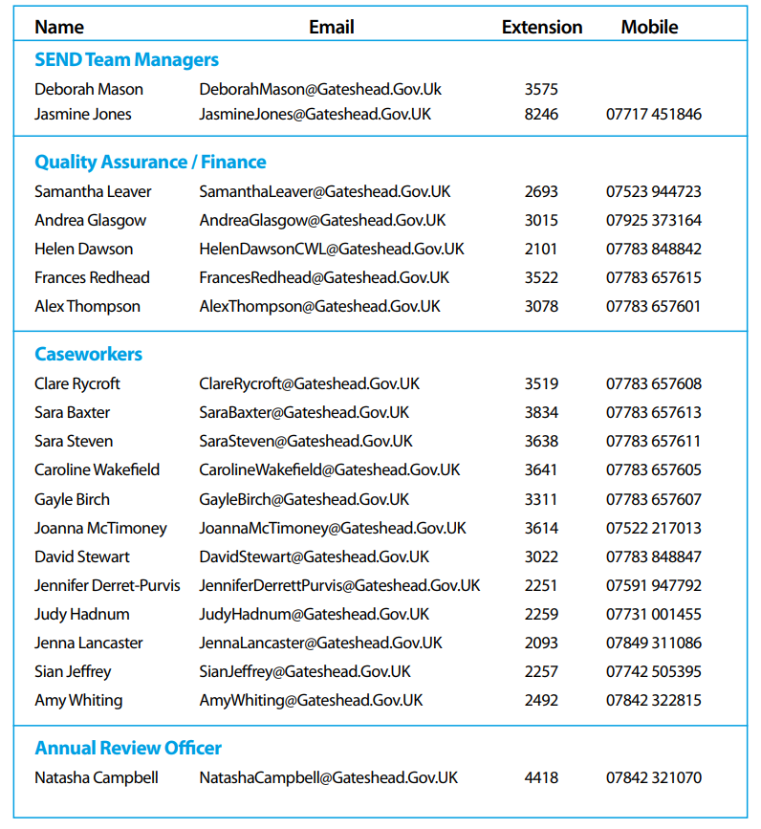

Summer Holiday Activities

Gateshead Council’s Brighten the Day team are delighted to offer a busy holiday programme, allowing the most vulnerable children access to free activities and enjoy even more healthy and nutritious meals during the school holidays.

There's lots going on right across Gateshead for children and young people of all ages. See the individual listings for more details and how to book a place. Please check before travelling for any drop in activities, and please note that Brighten the Day activities are for children on benefits-related Free School meals.
For more information, email brightentheday@gateshead.gov.uk

SMILE Through Sport have organised six weeks of holiday activity sessions and events for children and young people with SEND and their families to get involved in. Sessions are taking place across County Durham, Northumberland & Tyne & Wear! Booking is required for all sessions, which can be done via emailing info@smilethroughsport.com or visiting their website - https://smilethroughsport.com/whats-on/

The SEN Support Space is a Gateshead-based voluntary organisation which aims to provide children with SEND and their whole families opportunities to learn through play, socialise with others, and fulfil their sensory needs. They have a diverse programme of activities arranged for the summer holidays, all of which are fully inclusive and designed to provide safe and non-judgmental environments for children to socialise and play. Visit https://thesensupportspace.com/ or email thesenspace@gmail.com for information about what’s on!

Gateshead's Family Hubs provide a welcoming space for families to get the help they need on a wide range of issues. The Hubs are for families with children aged 0-19 years and up to age 25 for young people with SEND. There are currently six Family Hubs located across Gateshead, which offer a range of activities for children of all ages.
For more details visit https://www.gateshead.gov.uk/article/22551/Gateshead-Family-Hubs or check their Facebook page.

The Gateshead SEND Local Offer website has details of a range of SEND-specific leisure activities in Gateshead and the local area: https://gateshead-localoffer.org/family-information-service-and-directory/ The Events section also has details of a broader range of activities for children, young people, families and professionals.

Contact us!

Special Educational Needs and Disability Team
Gateshead Council
senteam@gateshead.gov.uk

0191 4333626
 Follow us on Facebook

