 | Hello! Welcome to Gateshead’s SEND Network Newsletter.  For more information about the SEND services available to you, go to www.gateshead-localoffer.org, follow the Gateshead SEND Local Offer Facebook page or visit the Gateshead Local Offer YouTube channel.
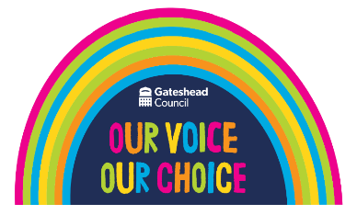           | Gateshead SEND Participation Strategy  Gateshead Council is launching its 2023-2026 SEND Participation Strategy this Spring. The strategy has been co-produced by Gateshead Council’s SEND Team, the Gateshead SEND Youth Forum, Gateshead Parent Carer Forum and Gateshead’s SEND Strategic Board.  “Our vision is that all children and young people have equal opportunity to meaningfully participate in the decisions that affect them”, says Councillor Gary Haley, Cabinet Member for Children and Young People. “We aim to embed participation across Gateshead and are consistently striving to improve our communication with children and young people who want to have a say on the issues that affect their daily lives.”  “We’re really proud of this strategy and hope that it can help to make a real difference in the lives of SEND children and young people across the borough.”  To access the strategy, visit https://gateshead-localoffer.org/gateshead-send-participation-strategy/  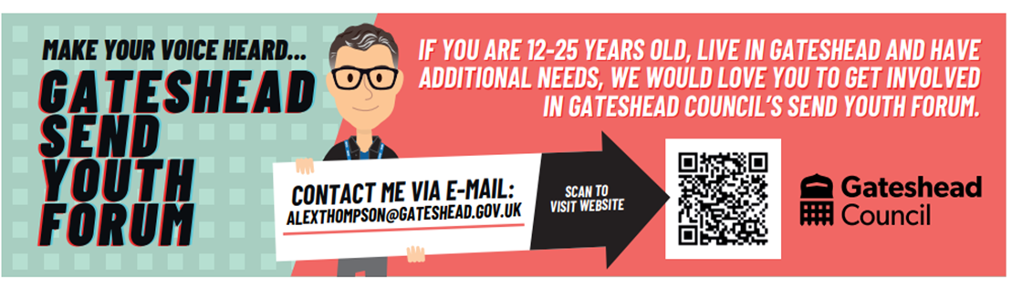  Gateshead’s New SEND Youth Ambassador  Gateshead’s New SEND Youth Ambassador  Hi, my name is Harry and I’m the new Youth Ambassador within the SEND department. I joined the team in late December 2022 with the ambition to develop my skills, meet and work with inspiring people and to give back to the community.  My role will have the opportunity to work with young people in Gateshead with Special Educational Needs and Disabilities and I want to hear opinions and concerns about lived experiences and the support young people receive.  I want to provide the best support possible in the form of information, advice, and guidance about the needs that people have and where and how they can pursue their ambitions. I work Monday to Friday based at Gateshead Civic Centre and I can’t wait to get involved and see what is round the corner.  I wish to make a real difference in the lives of the young people I will be working with and hope that supporting positive change for others will be a rewarding career to dedicate my time and efforts towards.  I really enjoy riding bikes and building Lego.  Gateshead Council’s SEND team strives to continually improve the services available to those with additional needs. For more information visit www.gateshead-localoffer.org or email harryvincent@gateshead.gov.uk  New Rules for Voter ID  Local government elections are due to take place on Thursday 4 May 2023. From May 2023 the law is changing to ensure that everyone who votes in UK elections will have to show photographic ID.  A broad range of documents will be accepted in order to prove your identity to vote. The Electoral Commission have created an easy read document to help those with SEND understand these changes:  Voter-ID-Resource_Voter-Booklet-Easy-Read_May-23_Group-6_0.docx (live.com)  Details of all of the help and support available to you can be found at  Voter ID - Gateshead Local Offer SEND 0 to 25 years (gateshead-localoffer.org)  Activities, Information and Resources  Four times as many boys are diagnosed autistic as girls. The Autistic Girls Network aim to raise awareness of autism in girls with health, social care and educational professionals and to bring change. Visit Home - Autistic Girls Network for more information.  Children North East are inviting those aged 11-17 to join their steering group and become a Young Advisor. It will be a chance to meet people across the region and develop a range of skills including leadership, communication and teamwork. For more information, contact louis.browning@children-ne.org.uk  Gateshead SEND Information and Support Service (SENDIASS) can help you with a range of SEND-related issues. For more information, visit Gateshead SENDIASS | Barnardo's or email daiss@barnardos.org.uk. Service users of Gateshead SENDiass have made a YouTube video explaining what the service offers and how they can help you.  Contact us  Special Educational Needs and Disability Team  Gateshead Council  senteam@gateshead.gov.uk  0191 4333626   Follow us on Facebook

