 | Hello! Welcome to the Gateshead SEND Network Newsletter.  For more information about the SEND services available to you, go to www.gateshead-localoffer.org, follow the Gateshead SEND Local Offer Facebook page or visit the Gateshead Local Offer YouTube channel.
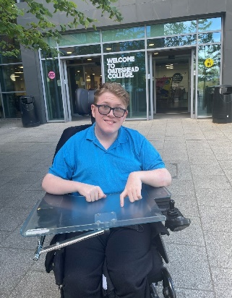  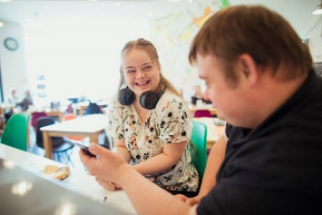    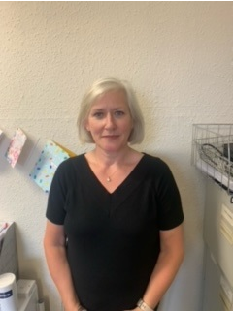  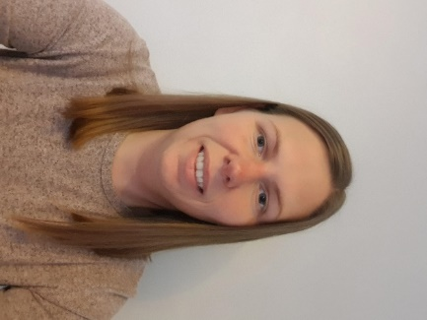  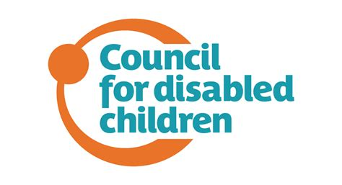         | Danny Moves to Mainstream  A young Gateshead student has taken the next steps in his educational journey. 19 year old Danny started a mainstream Level 2 Computer Science course at Gateshead College in September, after leaving the independent special school he had attended since he was a child.  “I was at Percy Hedley School since I was four,” says Danny. “I’m enjoying my new college but it’s been quite difficult. If you’re thinking of moving to a mainstream college I’d say start extremely early with transition - I started in June 2020! I’m still trying to get things better but I’m managing really well. In some areas I’d say I’m managing better than some of the other students in my class who’ve been in mainstream. I’ve gained a lot more independence via my education I’ve had my own drive to get into college.”  “I’ve found it a challenge and I’ve found it tiring - as soon as I get home I just want to relax! But college has been really flexible – mostly I’m only in for half days. The Learning Support Officers help me out - we come up with new ways of working so it’s kind of trial and error until you find what works best. I’d say that if you feel that you need to make changes or you’re not happy with something let a member of staff know. I’ve had to adapt and to be honest I’ve found it alright. I’m pleased I’ve done it. I feel my needs are being met.”  For more information about post-16 options available to you in Gateshead, visit Post-16 - Gateshead Local Offer SEND 0 to 25 years (gateshead-localoffer.org)  Gateshead SEND Careers Event  Gateshead Council hosted its second Careers and Transitions fair for SEND young people on Wednesday 19th October 2022. Taking place at the Dryden Centre, the event aimed to give young people and their families a wide range of information regarding the educational and employment opportunities available to them in Gateshead after leaving school.  The event included representatives from Gateshead’s Careers Information, Advice and Guidance team, Gateshead Learning and Skills, and many other local employers and agencies.  Feedback from the event was overwhelmingly positive. “I really enjoyed it,” said one young person. “It was useful meeting different kinds of people.” Parents and professionals also gave positive responses. “I found it really informative,” said one parent. “I found out about some new groups that are running in the Gateshead area which I hadn’t known about, so it’s been a really positive experience.”  Over 300 people attended overall, including 54 professionals who held talks, led workshops and managed stalls throughout the day. Many thanks to everyone who made the day such a success.  The Careers Information, Advice and Guidance (IAG) Team offers support up to the age of 19 for young people that have held an EHCP. Further information can be found at Careers Information, Advice and Guidance (IAG) - Gateshead Council  Gateshead SEND Information, Advice and Support Service  The Gateshead SENDIASS Team provide free, confidential and impartial information, advice and support to parents and carers of children and young people with SEND from 0-25 years old in Gateshead.  Hi, my name is Rebecca Pharoah and I’m the Children & Young People’s Worker at SENDIASS, I joined the team at Barnardos in September. I work 7.4 hours a week on a Tuesday and Wednesday. I’m able to meet with children and young people with Special Educational Needs (SEN) who would like to talk to someone about their support needs in school or college. I can also listen and support young people to give their views as part of the EHCP process or their views as part of their annual review.  If you need support or advice, please email me rebecca.pharoah@barnardos.org.uk or ring or text me on 07759119080  Hi, my name is Beverly Thornton and I’m a SENDIASS Officer working 2 days a week on a Thursday and Friday. I work alongside another SENDIASS officer, Linda Elliott. I started in this role in September. SENDIASS officers listen to parents and carers and offer independent, impartial advice on SEN issues and support parents and carers at meetings if needed.  I was a volunteer champion before I started a paid role and started volunteering with Barnardos 3 years ago, supporting parents to complete parental views forms. If you or anyone you know may be interested in volunteering with Barnardos to support parents and carers, please follow this link for further information:  https://volunteer.barnardos.org.uk/opportunities/32301-special-educational-needs-champion-gateshead-2022-05-19  If you need support from a SENDIASS Officer, please email DAISS@barnardos.org.uk or telephone 0191 4784667  Activities, Information and Resources  The Council for Disabled Children has developed a suite of free online training for members. The courses have been developed to improve knowledge, understanding and practical skills and support in a range of key areas that impact children and young people, particularly those with SEND. For more information visit https://councilfordisabledchildren.org.uk/what-we-do-0/e-learning  The GO Gateshead Access Card is a discount card that lets you experience sports and leisure facilities across all seven GO Gateshead leisure centres at a reduced rate. The card is available to Gateshead residents and their dependents who are in receipt of a qualifying benefit including Disability Living Allowance. To obtain a GO Gateshead Access card, pick up an application form at any GO Gateshead leisure centre, or visit GO Access card - GO Gateshead  Gateshead Parent Carer Forum has organised a series of coffee mornings for 2023. The sessions aim to provide parent carers with information about SEND services, as well as to offer an opportunity to meet for a chat and a cuppa! Meetings are held at the Metrocentre Community Hub from 10:30-12:30 on the following dates:  Wednesday 18th January  Wednesday 15th February  Wednesday 15th March  For more details of all their events, email info@gatesheadparentcarerforum.co.uk. For more information about the Gateshead Parent Carer Forum please visit https://www.gatesheadparentcarerforum.co.uk/  Contact us  Special Educational Needs and Disability Team  Gateshead Council  senteam@gateshead.gov.uk  0191 4333626   Follow us on Facebook

