 | Hello! Welcome to the Gateshead SEND Network Newsletter.  For more information about the SEND services available to you, go to www.gateshead-localoffer.org, follow the Gateshead SEND Local Offer Facebook page or visit the Gateshead Local Offer YouTube channel.
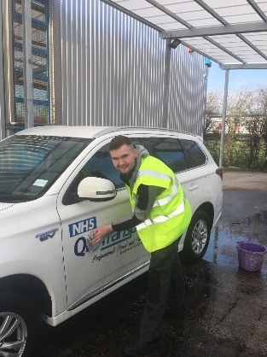  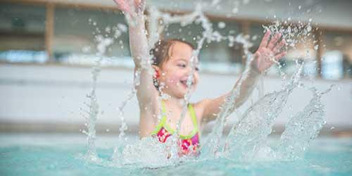  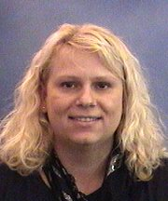    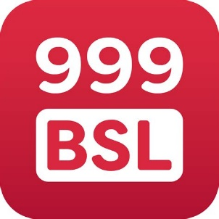       | Connor’s Pathway to Employment  Seventeen-year-old Connor Mudie, who attends Dryden School’s Sixth Form, has been offered a job with the NHS following a successful work experience placement organised by his school and Health Education England.  “I’m starting as soon as we get the paperwork sorted,” says Connor. “I’ve been doing work experience there for the past three months. I wash the ambulances and buses for other people to drive them. My job will be 20 hours a week over four days, from 10 o’clock to 3 o’clock”  “I like to work,” he says. “I wash my neighbour’s cars, I work for the school café making the food - I’ve been making sausage sandwiches! I like doing gardening – cutting grass – or working on the farm. I love doing these type of things. I’m just waiting for my wages to come through. I’d like more hours cos you get paid more!”  Connor is proud of his achievements and has praise for the help he has gotten from Dryden School. “I get loads of help when I’m at school. I talk to staff a lot about things that’s been happening when I’ve been outside of school. I’m definitely proud of myself. My mam and dad’s proud. Work experience has helped me. When I work problems go away - it makes me feel good about myself.”  More information about Gateshead’s Careers Information, Advice and Guidance team can be found at Careers Information, Advice and Guidance (IAG) - Gateshead Council. For more information about Dryden School visit their website or phone 0191 420 3812.  SEND Swimming Sessions  Go Gateshead are offering weekly SEND swimming sessions at Dunston and Blaydon Leisure Centres. The sessions are quieter and aimed at families who have children with special educational needs and disabilities.  Session times are:  Dunston Leisure Centre: Saturday 10am-11am  Blaydon Leisure Centre: Sunday 3pm-4pm  Proof of disability status is not required to attend these sessions.  For more information visit Swim session types - GO Gateshead  Gateshead Independent Travel Training  Hello, my name is Nicola. I have recently joined the Travel Care Team as the new Travel Trainer. The travel team help vulnerable people whose additional needs mean that they are unable to independently travel.  Young people tell us that being an independent traveller increases their confidence and self-esteem, reduces reliance on parents/family members, supports friendships and gives them a greater choice of post-16 curriculum options. I am a strong advocate for giving people the opportunity to have more choice, control and independence and I find the role deeply rewarding.  If you would like to contact me you can email nicolacharlton@gateshead.gov.uk or ring the Travel Care Team on 0191 4337484.  Gateshead SENDIAS Service  The SENDIAS (Special Educational Needs & Disability Information Advice and Support) Service provides independent impartial advice to parents/carers about their child's special educational needs, providing advice to children and young people about their SEN too.  Gateshead’s SENDIAS Service is provided by Barnardo’s Disability and Inclusion Support Service on behalf of Gateshead Council. They are open Monday - Thursday, 09:00-17:00 and Friday, 09:00-16:30.  For more information, visit Gateshead SENDIASS, email daiss@barnardos.org.uk or phone 0191 478 4667. Service users at Gateshead SENDiass have made a YouTube video explaining what the service offers and how they can help you.    British Sign Language 999 App  A new service has launched to allow people to make 999 calls using British Sign Language (BSL). The new service, called 999 BSL, allows deaf people to make emergency calls using an app or website, connecting callers with a BSL interpreter.  People who use the service will be put through to a BSL interpreter, who will then relay the conversation to a 999 operator.  The service is free to use and operates 24 hours a day, seven days a week.  It is available to download as a smartphone app and access as a web-based platform at 999bsl.co.uk.  Visit 999 BSL for more details and instructions on how to download the app. You can watch an introductory video at 999 BSL - YouTube.  Summer Holiday Ideas  Gateshead Council’s ‘Brighten the Day’ programme is again providing free activities for children and families during the school holidays, thanks to government funding from the Department for Education's Holiday Activities and Food Programme. The programme provides healthy food and fun activities for school aged children across Gateshead. Contact brightentheday@gateshead.gov.uk or visit Family activities and food 2022 - Gateshead Council for details.  Gateshead Children’s Centres and Gateshead Play Services have planned a range of groups and activities for children, young people, and families for the upcoming summer holiday. Membership of Gateshead Children’s Centres is free and enables families with children under 5 years to access a wide range of free activities and services. The Play Service provide activities and services for families with children and young people aged 5 years and over. For more information and details on how to join, visit the Gateshead Children’s Centres website or their Facebook page.  Seven Stories – The National Centre for Children’s Books in Newcastle – is open every day except Wednesdays in term time, and seven days a week in the school holidays. To see what’s on and plan a visit, click Seven Stories | The National Centre for Children's Books  North East Family Fun is a blog which publicises events and things to do for all ages and abilities across the North East, providing ideas for making the most of family life. Find out more at www.northeastfamilyfun.co.uk or visit their Facebook page.  Contact us  Special Educational Needs and Disability Team  Gateshead Council  senteam@gateshead.gov.uk  0191 4333626   Follow us on Facebook

